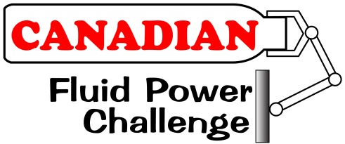
National Challenge
2017 Team Registration Form

Please complete the information below and return this form to fluidpowerchallenge@cfpa.ca.

Date of Submission: Click here to enter text.

School Name: Click here to enter text.

School Street Address: Click here to enter text.

City: Click here to enter text. Postal Code: Click here to enter text.

School Board or District: Click here to enter text.

Teacher-in Charge Name: Click here to enter text.

Teacher-in-Charge E-Mail: Click here to enter text.

Second Teacher (if applicable): Click here to enter text.

Second Teacher E-Mail: Click here to enter text.

To complete the registration process, please mail a cheque for $100 made out to the Canadian Fluid Power Association to 25-1250 Marlborough Court, Oakville, ON, L6H 2W7.

Once your school’s team is ready to submit its entry into the National Challenge, complete and submit the following information:

Student 1: Click here to enter text.

Student 2: Click here to enter text.

Student 3: Click here to enter text.

Student 4: Click here to enter text.

Date that Workshop activities were started: Click here to enter text.

Date that school team was selected: Click here to enter text.

Date that your team’s device was demonstrated: Click here to enter text.

