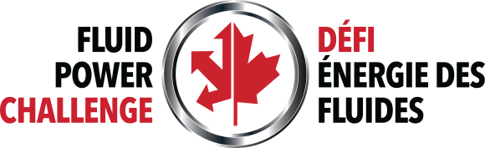
NATIONAL FLUID POWER CHALLENGE

PARTICIPANT FEEDBACK FORM

School (if applicable): Respondent’s Name:

Thank you for taking part in this year’s edition of the National Canadian Fluid Power Challenge. You can help us to make next year’s event even better by providing feedback about your experience this year.
Please rate us on the following criteria: (Enter E: Excellent: VG: Very Good: G: Good; F: Fair; P: Poor)
Criteria | Rating (please enter E, VG, G, F, P or N/A)) | Comments

Overall Experience
Curriculum relevance
How well did fluid power concepts we were trying to reinforce match the content of the Fluids section of the science curriculum at your school?
Workshop lessons
Lesson content and how easy these were to integrate into your regular classroom lessons
Appropriateness of the task
If the problem scenario was too difficult for your students, what, specifically made it too difficult?
Evaluation process
Was the progression from a whole class to a single team using National Challenge Rubric sufficiently clear? If not, what do we need to do to improve it for next year?

Continued on next page …

- The best thing about the entire Challenge experience was:

- Is there anything other than what you have shared with us in the table on page 1 that you would like to see changed?

- Do you think your school will participate in next year’s National Challenge?

Please complete this form and email it back to Bachmann.johnh@rogers.com.

Thank you for your feedback and your support of the Canadian National Fluid Power Challenge.

