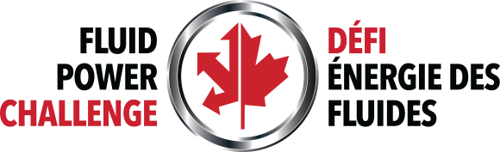

Student Media Consent Form

I, _________________________________________________, hereby consent to my
(Name of Parent /Guardian if Student is a minor-Under 18 Years of Age)
child _______________________________ being filmed, audiotaped, videotaped, and/or (Name of Student)
photographed by the media (print and broadcast), and employees, agents, or servants of the [Name of school board or district] on [Date] at the Canadian Fluid Power Challenge being held at [Location].
I also consent to my child being interviewed for the purpose of broadcast or print by the media, or the [Name of school board or district].

_____________________________________________________________________________ __________________________________________________________
(Signature of Parent/Guardian) (Date)

